Student Name: Dang Khoa Le

Student ID: 103844421

Tutorial Session: Wednesday 8.30 AM

Design Draft for Education Website

1. Introduction

The Educational Website is a comprehensive online platform designed to facilitate learning across various subjects such as Mathematics, Physics, Chemistry, Geography, and History. Leveraging my understanding of HTML, JavaScript, CSS, and constructors such as Vue.js and Bootstrap, the site features an intuitive design that incorporates interactive elements and algorithms to enhance user engagement. Key implementations include:

* Utilization of Vue for dynamic content rendering and seamless user interactions.
* Implementation of tables to organize and present information effectively, aiding in the visualization of complex data.
* Filter and Lookup algorithms assorting out data.
* Fetch and read data files to construct webpage table.
* Integration of credential verification for secure user authentication, enabling seamless login and logout processes.
* Incorporation of APIs to fetch and display relevant content, enriching the user experience with real-time data.

2. Specific Descriptions  
**a. Menu page:**This page mainly server as a Menu / User Interface page to direct users towards different sites in this project. Which satisfy the requirement of excellently demonstrating usage API.

After processed through the credential step, user is redirected to the Menu page, where different sites are provided from Questionnaires, Classrooms to Social Media pages, users can click on any of those to direct them to the requested page. An image illustrating different sites is also provided for a better visual effect.

User can also log out when clicked to the “Log Out” button on the bottom right side of the interface and leaves rating on the “Rate Us” button.

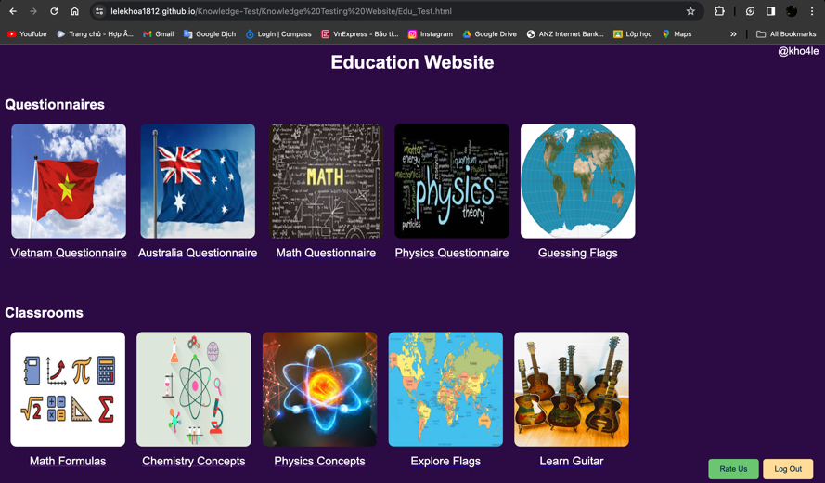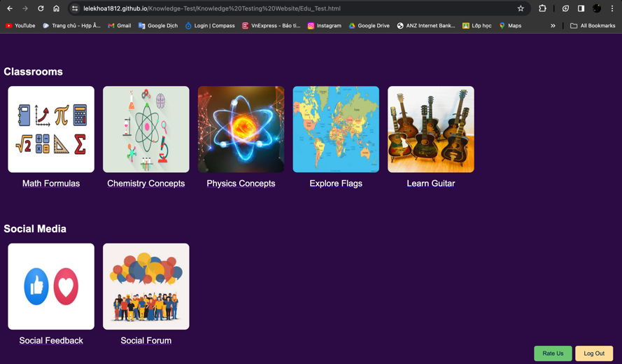The username (or userid variable) is also extracted and displayed on the top right side of this page, corresponding to the user currently using the webpage (shown as “@username”).

When logging out, the current user data will be removed but not deleted. Hence, user can log in again with a different account without any error existence.

**b. Credential:**

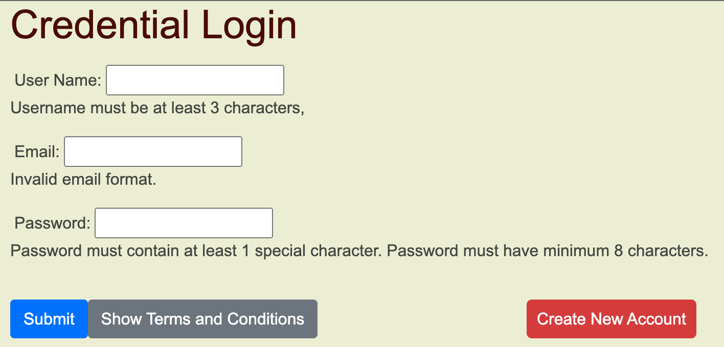Credential login functionality where users can Login to their account or Create New Account. User’s account will be pushed, sorted, and stored on localStorage, which is saved in an SQLite file in a subfolder in the user's profile.

An account consists of username, email and password components. Username must be at least 3 characters, email must contain ‘@gmail.com’ as the domain and password must be at least 8 characters with 1 special character.

Once an account is created, its username will be used to filtrate the corresponding email and password for later attempts to logged in this account, hence, performing accurately all credential activities.

“Terms and Conditions” can also being shown upon clicking.

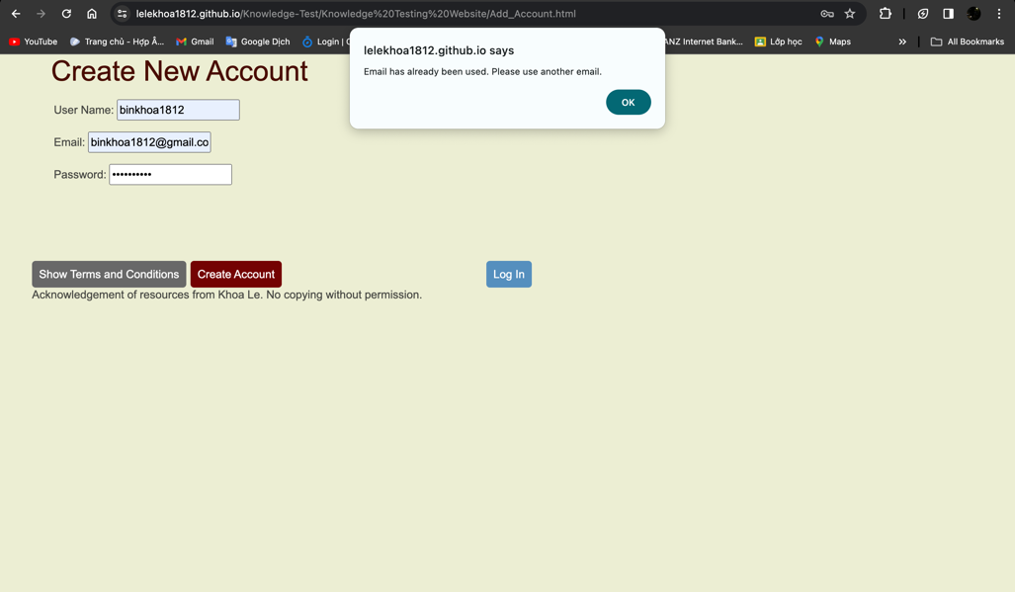Additionally, an error message will be announced to the user if their account created used an existing username or email (matching any record data of username and email), hence, ensure seamless operation and avoid error.

**c. Questionnaires:**

Questionnaire sites provide an environment for users to test their knowledge on different topics, their point will be calculated and provided to them at the end, reflecting their knowledge base on that given topic.

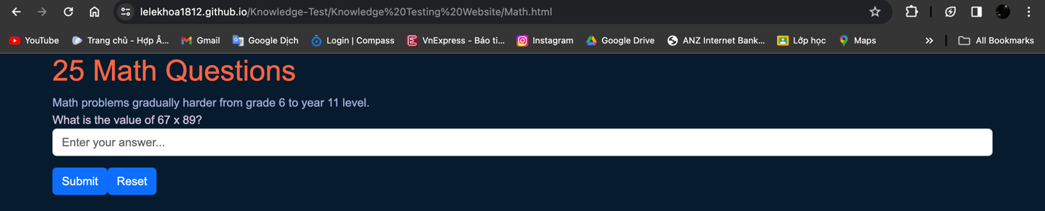Multiple scientific-topics Questionnaires are implemented such as Math Questionnaire and Physics Questionnaire, which contains 25 questions from grade 6 to 11. All answers are saved as in the code file as array, while user’s answer will be used to check if it matches the answer component by that question array’s. User can reset their current question attempt as well.

Country knowledge topics such as Vietnam Questionnaire and Australia Questionnaire present 40 multiple choices tests with topics related to Food, History, Landscape and Geography. These test’ order is scrambled so that they will not being displayed on a fixed order sequence. User can reset their current question attempt as well.

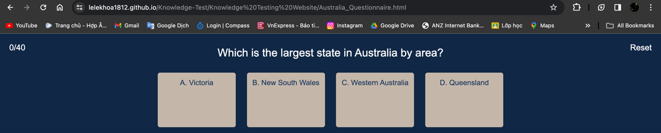All questions data locate inside the html code file to that webpage as arrays. User’s point is incremented and calculated on the top-left side, which point will be used to execute corresponding message to the score, alerting to the user.

Figure. Message alert to the user’s score.

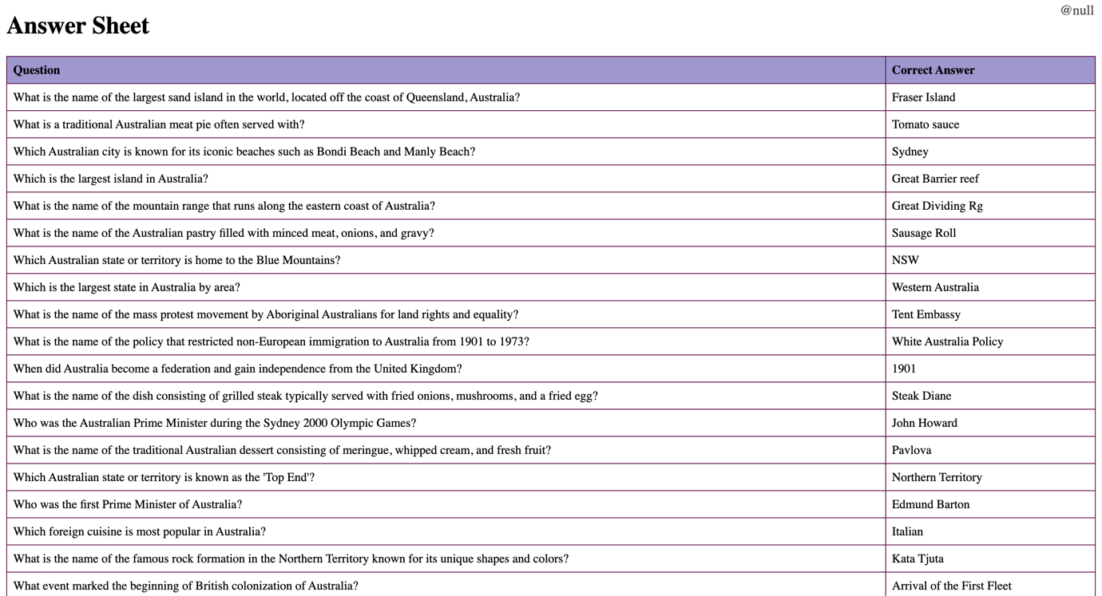Upon finishing these scientific and countries topic questionnaires, user can also check their answer. Whilst answers are saved in question arrays, these will be forwarded to answer_sheet.html code, which contain algorithms to fetch and construct the question arrays as a table to show user the correct answer to the test they have just done.

A questionnaire “Guessing Flags” is also introduced to test user’s knowledge on distinguishing countries’ flag around the world. This questionnaire used the quite similar website constructions to the Math Questionnaire and Physics Questionnaire, while also importing images data from the server.

**d. Classrooms:**

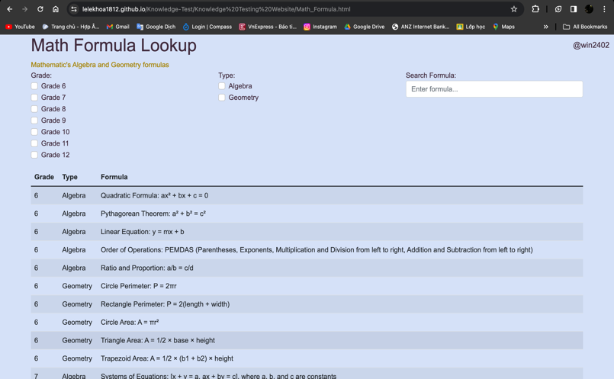Introducing innovative features, the Classrooms workspace, including Math Formulas (Algebra and Calculus formula from grade 6 to 12), Physics Concepts and Chemistry Concepts (Theory and Formula concepts from grade 6 to 12). All databases are JSON file to be read from the server (i.e. my GitHub account).

These data will be formatted by using Vue construction to create table with proper implementation of rows and columns, legends and lookup filter (search bar and tickbox) to search for any specific data on request.

Next, we have Explore Flag site, where user can look up for up to 40 flags from different countries around the world. Flags data is saved on server (my GitHub account) and constructed as a table with that Country’s name and the flag image.

This webpage implement pagination functionality.

User can filtrate the flag they need to look up as tick on the box to sort them out by Region or Continent. The first 10 flags show the answer to the Guessing Flags questionnaire site as well.

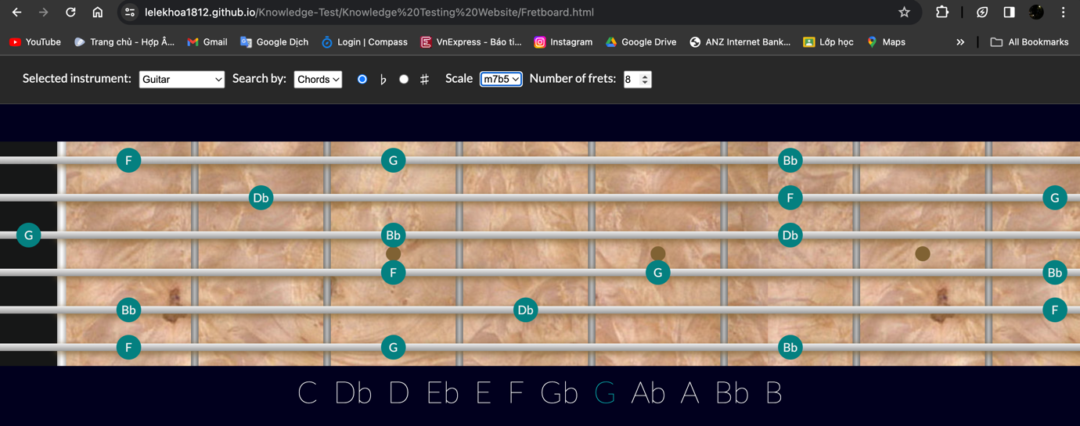Additionally, there is an initiative design of Learn Guitar (Fretboard) site where user can search for guitar’s note, chord, and scale position on the Fretboard. This initiative design is implemented from one of my individual project outside of this unit.

The Knowledge Contribution workplace, is expected to be finalised soon, allowing users to contribute their knowledge and collaborate with others (view, add, delete, and update yourself and other formulas or theories by any subject at any grade).

While using this classroom environment, users can access educational lessons and materials, to expand and acknowledge themselves. These sections utilize Vue construction and MariaDB for efficient data management and storage.

**e. Social Network:**

Addition of social networking elements such as Social Feedback and Social Forum, empowering users to provide feedback, communicate with developers, and share their experiences with others, thus fostering a vibrant online community dedicated to learning and knowledge exchange.

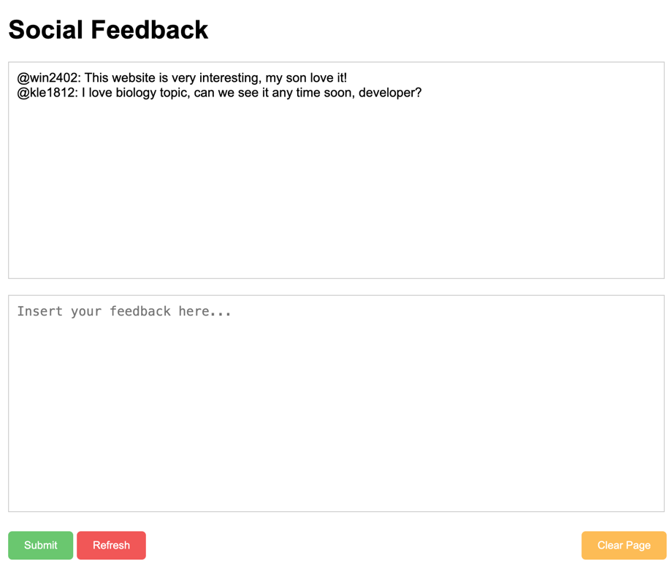Social Feedback webpage allow users to leave feedback as text-messages, enable them to request the developers improving the Website, raising user’s interaction.

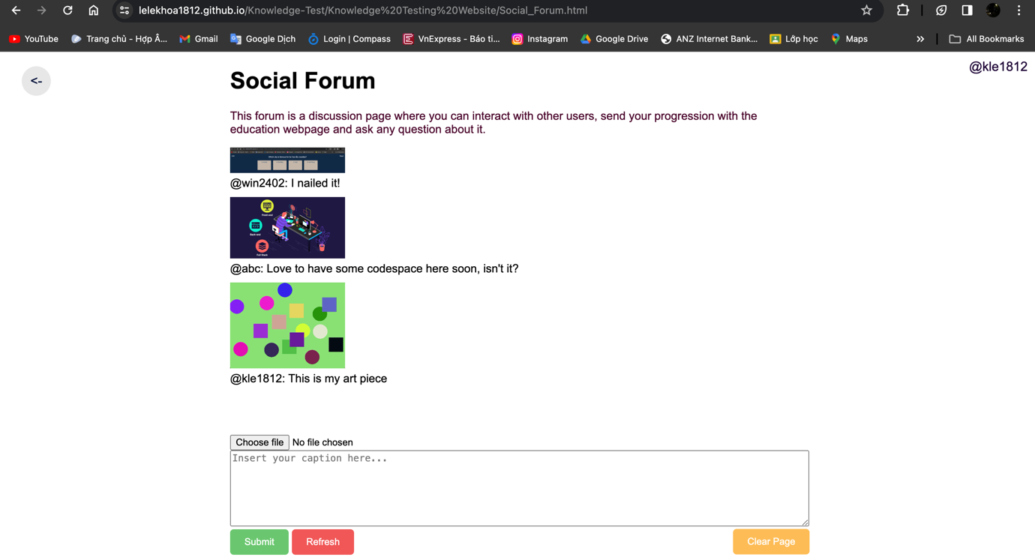Meanwhile Social Forum allow users to leave both text-message and upload images dually, allow an open-space for user to discuss and collaborate on their acknowledgement, or share their achievement while using the website.

Upon clicking on the “Rate Us” button from the main menu, a modal box will be displayed to request user’s ratting to the website.

Rating functionality also implemented as users can leave their rating from 1 to 5 stars to the developer of the website, the number of feedback-star provided can be save and incremented by type from 1 star to 5 star each time user leaves their feedback about this website.

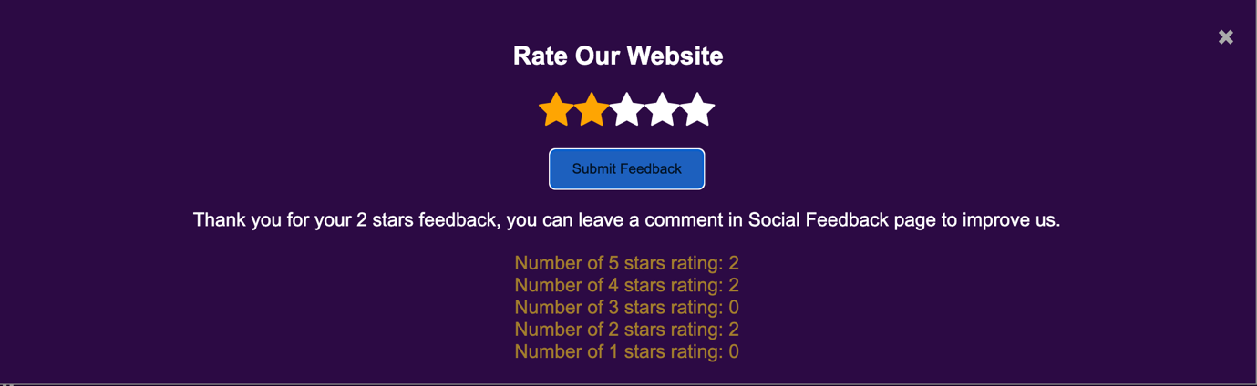

Current website version is accessible via this link (hosted on GitHub, excluding the Contribution section, which is on progress): <https://lelekhoa1812.github.io/Knowledge-Test/Knowledge%20Testing%20Website/Credential.html>